Classroom Management Philosophy Paper
Emily Steffl
December 13, 2015

My teaching philosophy is "I desire to use my passion for learning and teaching to inspire hope in each and every student so they can succeed and attain their highest potential." The only way that this philosophy can truly work is if I have a way to implement this into my classroom through classroom management and being an effective teacher.
Harry Wong describes three characteristics that make up an effective teacher. An effective teacher must have "classroom management, lesson mastery, and positive expectations" (Wong, 2014, p.2). I will now link Wong's three characteristics with my philosophy.
Classroom management shows that I am the teacher and that I know how to facilitate learning effectively. The ideal location where students can best learn is in an atmosphere that is equal, safe, and supportive. If one of these is not exhorted in the classroom, there will be deficits and drawbacks. Those deficits will then be reflected on you and to question (to a certain extent) why no advancements are made. An example of this would be disorganization in a grocery store. If the shelf-stockers are not doing their job by refilling the shelves for the customers, how can the business expect to succeed if there is nothing in place for the costumers to buy?
Lesson mastery is really the basics of teaching. If a teacher cannot teach, why are they a teacher? If a teacher does not know how to accommodate certain students who may have disabilities or impairments, why are they teacher? A teacher must be flexible and be able to connect with the students to ensure learning. A teacher monitors this by knowing appropriate standards to grade level, student interaction in class, and through assessments. "A lesson plan is the instructor’s road map of what students need to learn and how it will be done effectively during the class time. Before you plan your lesson, you will first need to identify the learning objectives for the class meeting. Then, you can design appropriate learning activities and develop strategies to obtain feedback on student learning" (CRLT, 2015).
Positive expectations are a significant part to being a teacher. In this paper I have included a section on student expectations. The student needs to know that they have to do their piece to ensure that they will learn and grow in presented knowledge.
I believe that if a teacher has a combination of these three characteristics, they will get the most from their students. I can manage my classroom with control while presenting knowledge and facilitating learning by holding my students to a standard. Every teacher wants to be successful and see their students succeed and by taking the initiative and owning the classroom can make your students excited about learning.
In this philosophy paper I will discuss what it means to me to be an effective teacher through classroom management.
Before School Starts: The Set Up
Climate of the Classroom
I firmly believe that a classroom needs to implement a learning atmosphere that will attract to all students. I want my students to feel welcome and that I will give them all the tools that I can for them to learn. In this section, I will discuss the layout of my classroom and my role of carrying out classroom management procedures.
The layout of my classroom will be divided into sections based on what I expect from my students. "What may be more important than these items, however, is the way the internal features of your classroom (desks, chairs, tables) are arranged. Students quickly get used to accept the external features of a classroom, good or bad. But the internal arrangement of the classroom will affect your students every day of the year" (Boric, 2014, pg 80). The picture below is an example of my classroom layout. I would have the SMART board at the front of the room to show that all learning instruction will take place at that location. The meeting rug will represent the area of brainstorming and the exchanging of ideas together. I really emphasize the rug as a space of group collaboration. Learning is not always done alone and I think students forget that group work can help implement learning and "move some gears." Some group collaboration examples would be "pair-share" or "turn-and-talk- partners." This would also be the area where presentations would occur where the student or teacher is presenting a topic and is expecting the listeners to be active listeners. Again, this space is intended for all students to put their heads together and share their ideas under direct instruction.
Next, take note that my desk will be in the corner of the room. This location shows that I do not want to be the focus of the classroom, but instead a mediator to fasciculate learning. I want to show that I, the teacher, am here to help you, the students, learn. I will give them all the tools that I can for them to learn, but what they will do with their tools is completely up to them.
In the back of the classroom I would put my comfy reading area. This area would include bean-bag or circle chairs. I would have different lights that would set a more relaxed mood and a place where students can simply just curl up with a book and read. This area is located in the back of the classroom because I don't want it to be a distraction to the SMART board learning area. As I have said, the SMART board is an area for direct instruction and the comfy area is for indirect instruction where the student takes control of their own learning and reading.
Lastly, the middle of the classroom is the students. The students' desks would be arranged into pods to encourage group collaboration. This is also an area of indirect instruction as well because all direct instruction will occur at the SMART board.
I will implement classroom management according to my classroom setup. This means that I will keep my rules concise and simple. For example, when a student is in the comfy reading area, they know that they are working by themselves quietly to achieve personal best. The contrast is the SMART board that encourages active participation with your neighbor. I have to make sure that all of my rules are practical and that I know I can carry out and follow through. Once I have shown that I will follow my rules and procedures, the basics are in place.

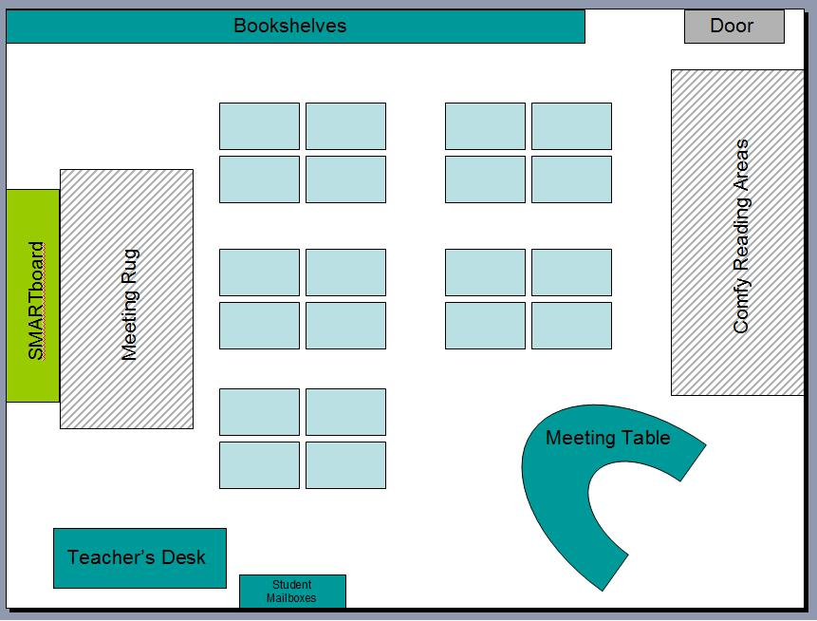

The Expectations
On the first day of school I will welcome my students to class and share with them I have high expectations for everyone. This is not meant to scare them from learning, but instead to show that I want them to learn and to take responsibility to learn in my classroom. "This is the time to revolve student uncertainties and let your learners to know what to expect. There is no better way to begin this process than by referring to the conduct and work rules that you have either posted for all to see or provided as a handout" (Borich, p. 94). I prefer to use the term expectations instead of rules. When students hear the word 'rules' they automatically shut down and think of them as constricting instead of helpful. The expectations that I would have for my classroom would be BE RESPECTFUL, BE HONEST, BE RESONSIBLE, BE GREATFUL, and BE KIND. I think these expectations are concise, to the point, and not too unachievable.
The Welcome Letter (see attachment)
Before the first day of school, I would send a welcome letter to all of my students and their families. This would give a quick informal greeting to parents before I meet them in person. The letter would show my excitement for the upcoming year and that I am dedicated to creating a learning environment for their child. I would include information on myself and how to best contact me if there were any questions or concerns. This letter would continue throughout the school year to keep the parents involved and connected with their child's education.
Greet Your Students
I have seen this done in many different types of settings and I think it adds a personal touch to the classroom. Not only on the first day, but every day, the teacher should greet her students at the door. This action shows the students that they are appreciated and welcomed into the classroom. It also shows that the teacher is ready for the school day and all that entails.
Procedures
Getting Student Attention
I have three strategies that I would like to implement in my classroom to get students attention. The first was from a video Getting Attention by Rob Plevin. He suggests using sheets of paper that represent traffic lights. The green color would represent good appropriate noise level. The yellow would represent that they need to take note and manage their noises. The last, red, would mean that students need to quickly turn all noises off in 30 seconds and direct all attention to the teacher. At the red light, the teacher needs to reteach and reinforce.
The second strategy I have learned is from my PE methods class. Clapping different rhythms and requiring your students to repeat them back to you. The students who are listening and attentive will clap and help bring those who are not listening to get back on track. This strategy holds the students accountable to each other and the teacher who is asking for their attention.
The third strategy I have learned is from my practicum teacher. She sent me a page that has many different callbacks to get your students attention. For example, "hocus pocus" with students replying "everybody focus." I have attached the page she sent me in the back of the paper.
Student Jobs
In my future classroom I would assign each student to a job. I had seen this done in my practicum school. My practicum teacher had assigned roles of the classroom to each of her students. For example, one role was electrician who was in charge of lights or another student was teacher helper who made all the trips to the office. I really liked this management skill for many reasons. First, it made the student feel needed or part of the system. He or she had a role and they were needed to ensure that the role was carried out! Secondly, it held the student responsible to complete the goal. "If we want to teach children to be responsible, we have to trust them with responsibilities. Classroom jobs are an effective way to enlist students in the duties of running a classroom, promote positive behavior, and ensure that all students feel welcomed" (TeachForAmerica). The student knows their job and knows that they need to complete it to ensure that all continues to run smoothly in the classroom. Third, the student jobs helped other students hold their peers accountable. For example, if Jenny forgets to go to the office to get the class snack at snack time, the other students will remind her of her job. Their reminders show that Jenny is important because the rest of the class is recognizing that they need her to do her job. Other jobs that I would have in my classroom would consist of desk cleaner, mail carrier, substitute teacher helper, scrap monster, sanitizer.
Discipline
Love and Logic
Jim Fay provides his readers with great tips to incorporate love and logic into disciplining. With Love and Logic, Fey provides five steps to take in managing a discipline strategy. The first is to "build positive relationships with your students." As a teacher, you should get to know your students and find out what their hobbies and interests. Next, "set enforceable limits through enforceable statements." Don't set something you cannot enforce. Third, "share control." Fourth, "implement disciplinary interventions that stop undesirable behaviors in their infancy, avoiding the need for consequences." Lastly, "delay consequences." This strategy gives the student time to reflect on their actions and think about how the teacher will act/discipline. The adult or teacher in this strategy has the 'edge' as they can take their time to think of an action and not let the student distract from their teaching. (Fey & Funk, 1995, p. 44)
An example of this could be I have Sam in the back of the classroom with his head down on the desk during individual work time. I approach him and ask why he isn't doing his work. In this situation I have two options. A.) Tell him this is his job and if he continues to act this way, he will get a zero. B.) Give him the option of either to do the assignment now or it will become homework and I expect it for tomorrow. If he begins to protest that he doesn't want to do it either way I would say, "I hear you. However, I want to make sure you understand this lesson. If you don't understand this, that means I am not doing my job as the teacher. Will you please do your job as the student?" This response puts the student first and shows that I am not giving the assignment as a form of punishment, but as a form to see if HE is learning what I am teaching.
Conclusion
I have so much more I could include in this classroom management philosophy paper; however, it is a good start to my first year of teaching. This paper will only grow longer as I gather more management tips from other teachers and from personal experiences. I have learned a lot so far in my education and am excited to continue!

References

Boric, Gary D. (2014). Effective Teaching Methods: Research- Based Practice. New Jersey: Pearson Education, Inc.

Do You Have An Ideal Classroom Layout? | Top Notch Teaching. (2012, April 23). Retrieved December 13, 2015, from http://topnotchteaching.com/time-saving-tips/classroom- layout/

Fay, J. & Funk, D. (1995). Teaching with Love & Logic: Taking control of the classroom. Love & Logic Press Inc: Golden, CO.

TeachingForAmerica. (1996-2009). Teaching as leadership. Retrieved from http://teachingasleadership.org/sites/default/files/How_To/INV/I-5/I- 5_Classroom_Jobs.pdf

Top Notch Teaching. (2012). Do you have an ideal classroom layout? Retrieveed from http://topnotchteaching.com/time-saving-tips/classroom-layout/

Wong, Harry K. (2014). The Classroom Management Book, California: Harry K. Wong Publications, Inc.

Hello Fourth Grade Parents!
My name is Miss Steffl and I will be your child's fourth grade teacher. I am looking forward to hopefully meeting you and having your child in class. I just thought to give a little background about myself before I formally meet you!
I was born and raised in New Ulm, Minnesota. After high school graduation I attended the University of Mary in Bismarck, North Dakota with a double major in Elementary and Early Childhood Education and a minor in Special Education. This is my first year in the district and I am very excited to begin the career that I have dreamed of since a little girl!
If you have any questions, comments, or concerns now and throughout the school year, please do not hesitate to contact me.
Thank you and let the school year begin!
Miss Steffl

Phone: 000-000
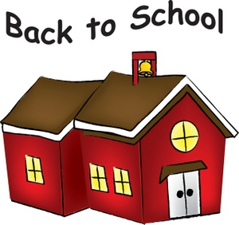
Email:

